|  |
| --- |
| Name: |
| Student Reference Number: |



|  |  |
| --- | --- |
| Module Code:  PUSL 2024 | Module Name:  Software Engineering 2 |
| Coursework Title: | |
| Deadline Date:  31/01/2024 | Member of staff responsible for coursework:  Mr. Pramudya Thilakaratne |
| Programme:  BSc (Hons) Software Engineering | |
| Group work:   |  |  | | --- | --- | | Student Id | Name | | 10898630 | Jayamuni Rashminda | | 10815319 | Onaliy Jayawardana | | 10898638 | Udugodage Rodrigo | | 10898432 | Dona Bodhinayaka | | 10898484 | Kariyawasam Induwara | | 10898598 | Waniga Perera |   ***We confirm that we have read and understood the Plymouth University regulations relating to Assessment Offences and that we are aware of the possible penalties for any breach of these regulations. We confirm that this is the independent work of the group.***  Signed on behalf of the group: | |
| We have not used translation software. | |
| **Overall mark _____% Assessors Initials ______ Date_________** | |

Contents

1. Abstract 3

2. Introduction 4

3. Identified Process 5

4. Use Case Diagram 6

5. Class Diagram 7

6. Sequence Diagram 8

7. ER Diagram 9

8. Samples of the Developed System 10

8.1 Home Page for All Users 10

8.2 Home Page for Users Logged In 12

8.3 Home Page for Admin 12

8.4 Category Options 13

8.5 Category Pages 13

8.6 Sign Up Page 17

8.7 Login Page 18

8.8 Track Orders Page 18

8.9 Delivery Details Page 19

8.10 Search Function 19

8.11 Cart Page 20

8.12 Avoid Order Collisions 20

8.13 PayPal Payments 21

8.14 Payment Confirmation 21

8.15 Feedback Form 22

8.16 Product Pages – Admin 23

8.17 Add Product Page - Admin 23

8.18 Update Product Page - Admin 24

8.19 Delete Product Page - Admin 24

8.20 Dispatched Items Page – Admin 25

8.21 Stock Page - Admin 25

8.22 Un Dispatched Item Page – Admin 26

8.23 Email Notifications 26

# 

# Abstract

In an era where the supermarket industry is continually evolving, the importance of a robust online presence cannot be overstated. This abstract introduces Green supermarket, an innovative online selling supermarket website designed to provide customers with a seamless and convenient shopping experience. Green supermarket is a digital marketplace that transcends the limitations of traditional brick-and-mortar supermarkets, offering a diverse array of products ranging from fresh produce and groceries to household essentials and specialty items. The platform provides an intuitive and user-friendly interface, ensuring hassle-free navigation for the populace.

The website is partitioned into two modules namely the customer interface and the admin workspace.

This web-based system facilitates customer interaction with products through a user-friendly interface. To engage with product details, customers are required to register, allowing them to make inquiries, view product details, and make purchases with the convenience of home delivery.

The admin module includes the authority to manage product information through tasks such as adding, deleting, and updating details. Additionally, administrators can customize various aspects of the website to meet evolving requirements, ensuring adaptability. The module also facilitates system oversight, allowing administrators to monitor customer activities closely, thereby ensuring a seamless and secure user experience.

# Introduction

Green Supermarket, a stalwart in the supermarket industry, has witnessed significant evolution since its inception. However, one area that has lagged is its online presence, particularly its outdated website. Recognizing the imperative of aligning with modern consumer expectations and industry standards, the decision to revamp the website has been made. This report outlines a comprehensive strategy to modernize the online platform of Green Supermarket, incorporating cutting-edge technologies such as Java JSP, and Servlet.

The envisioned transformation involves not only addressing current drawbacks but also proactively incorporating features that are now integral to a seamless online shopping experience. The introduction of online shopping capabilities streamlined online payment processes, collision avoidance mechanisms, visual representation of customer feedback for managerial insights, and real-time communication through email notifications are pivotal components of this overhaul.

By embracing Java JSP, and Servlet technologies, this initiative aims to ensure a responsive, user-friendly, and dynamic online interface. These technologies are selected for their versatility and compatibility, allowing for the integration of modern features while maintaining a robust and scalable architecture.

The ensuing sections of this report delve into the specific components of the proposed transformation, providing a blueprint for implementation. The ultimate goal is to position GREEN Supermarket at the forefront of digital innovation within the supermarket industry, enhancing customer satisfaction, operational efficiency, and overall competitiveness in the evolving retail landscape.

# 

# Identified Process

**1.User Registration and Login:**

• A secure user registration and login system to personalize user experiences.

**2.Admin Login:**

• A secure admin login where admin has a separate view to manage inventory and orders.

**2.Online Shopping:**

• A user-friendly interface for browsing products.

• Enabling customers to add items to their cart and proceed to checkout.

**3.Order Tracking:**

• Enabling customers to track their orders and know whether they are shipped or not.

**3.Online Payment Handling:**

•Integrating secure payment gateways (PayPal) to facilitate online transactions.

**4.Avoid Shopping Collisions:**

• A real-time inventory system to prevent overselling or conflicts in product availability.

**5. Visualization of Customer Feedback:**

• A dashboard for managers to analyse customer feedback.

**3.Inventory Management:**

• Admin can add new inventory, update existing inventory, update the stock amount, and delete products

**6.SMS/Email Notifications:**

• Automated notifications for user registration, purchase confirmations, order cancellations and stock addition.

**8.Responsive Design:**

• The website is responsive for a seamless user experience across various devices.

**9. Security Measures:**

• Robust security measures to protect user data and transaction information.

**10. Integration Testing**:

• Ensured thorough testing to ensure seamless integration of the new features without compromising existing functionalities.

# 

# Use Case Diagram

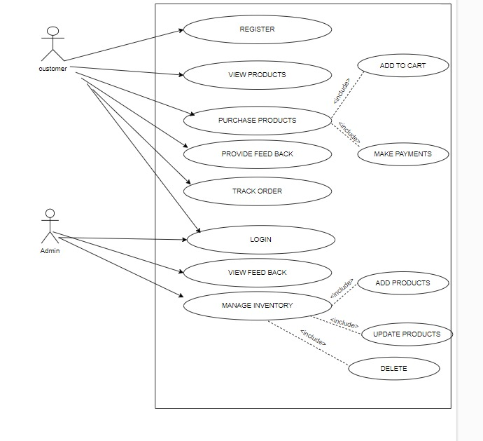

# Class Diagram

# Sequence Diagram

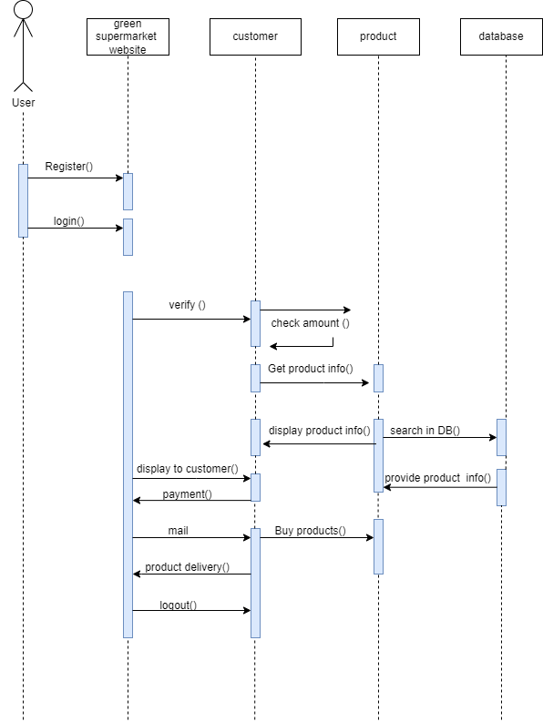

# A diagram of a company Description automatically generatedER Diagram

# Samples of the Developed System

## Home Page for All Users

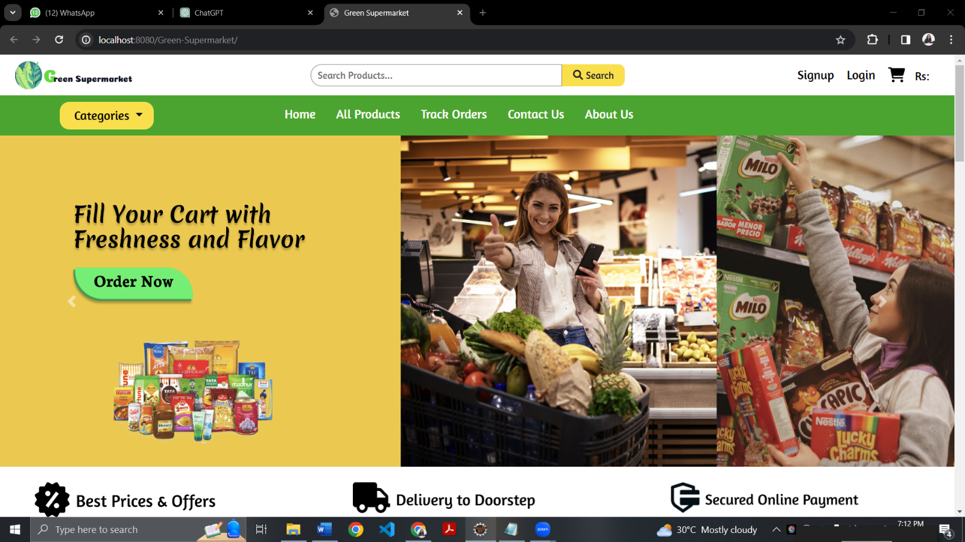This is the home page which will be displayed for all the visitors of the website.

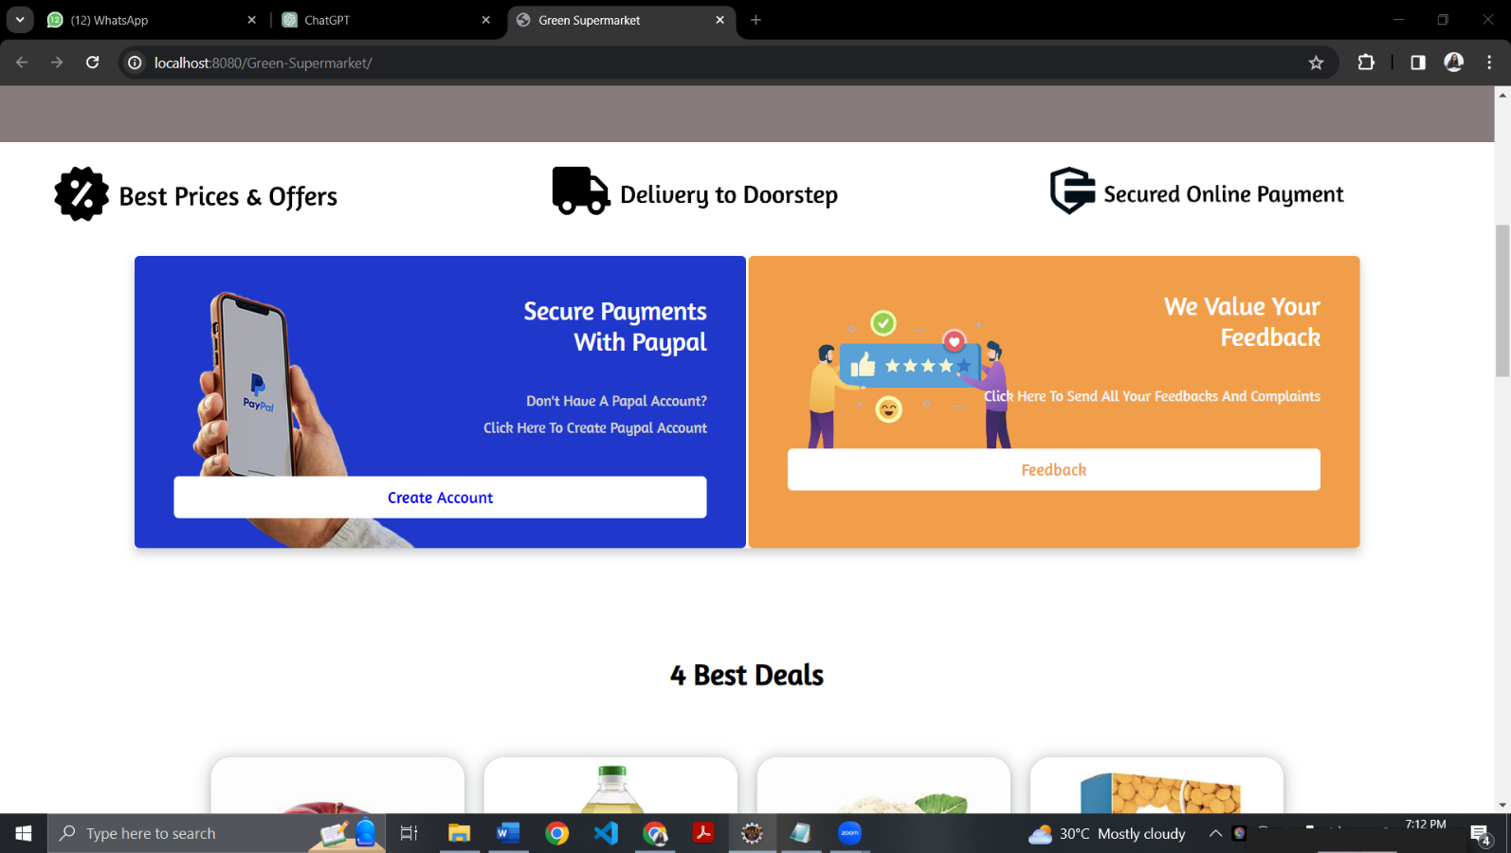

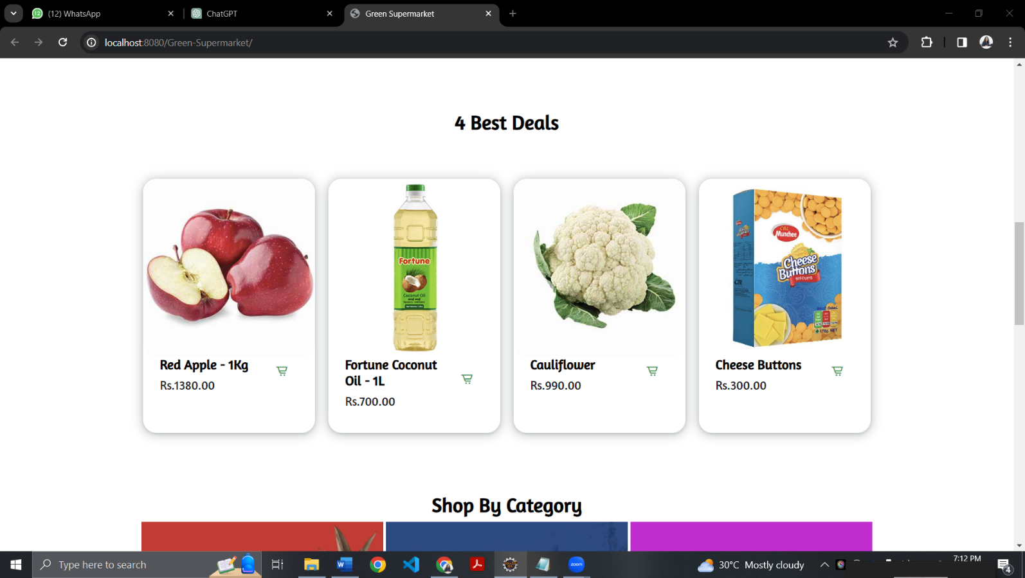

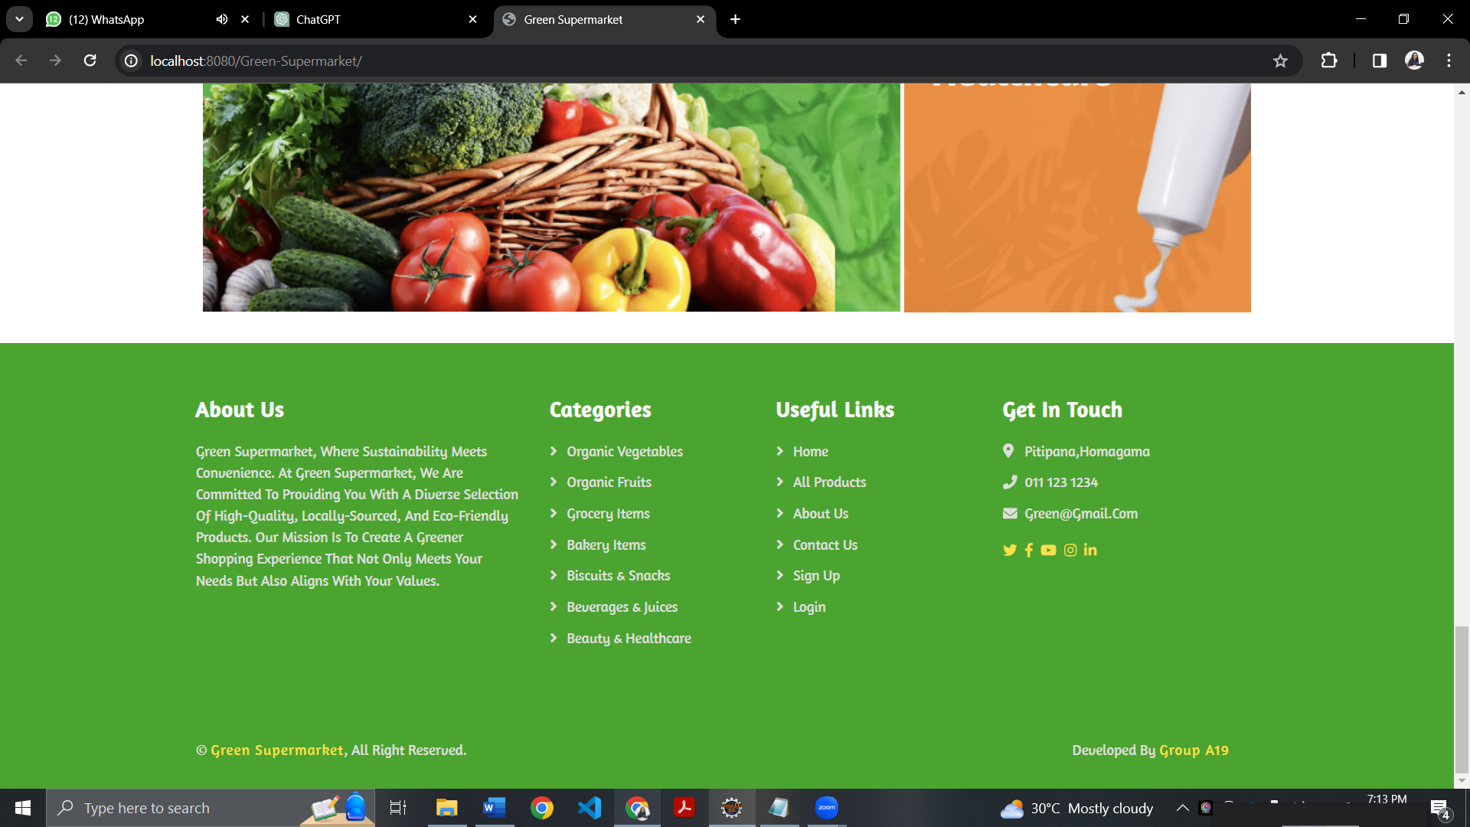

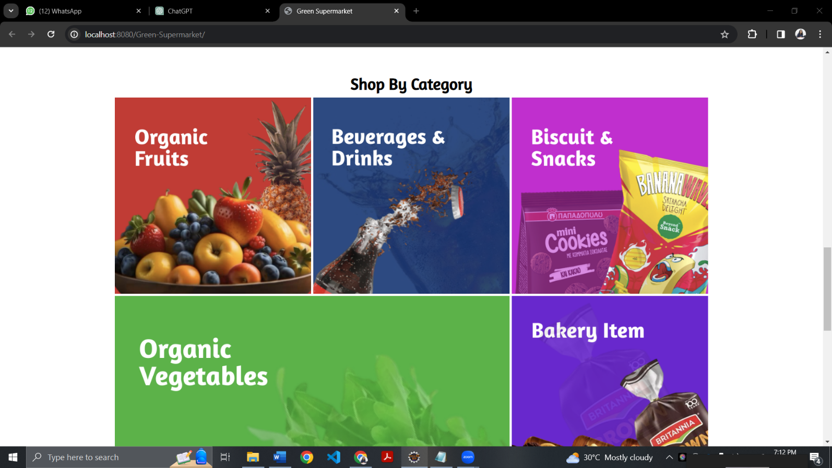



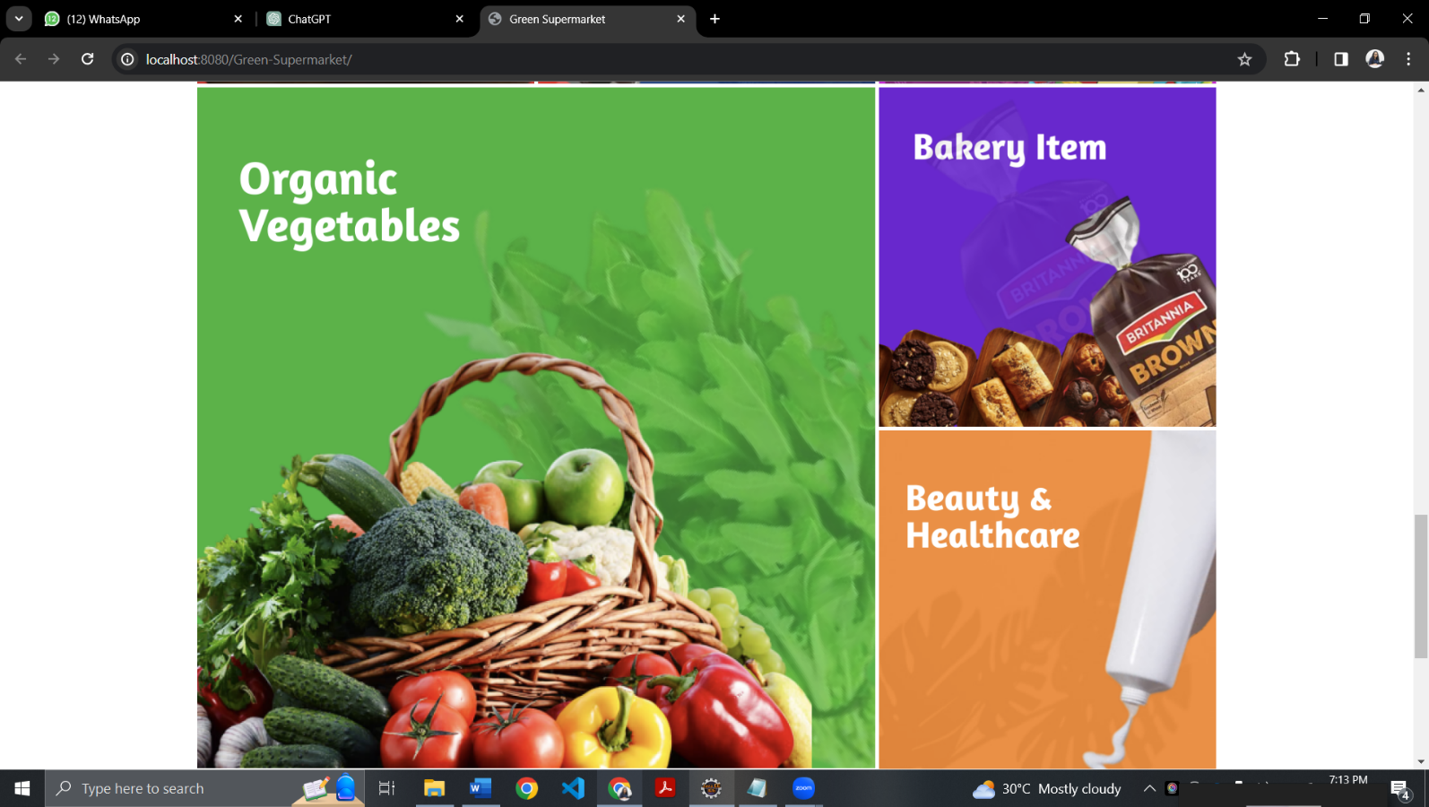



## Home Page for Users Logged In

The users who are logged in to the website views a home page with a different navigation bar with extra options such as Track Orders, Profile, Contact Us, About Us and Cart

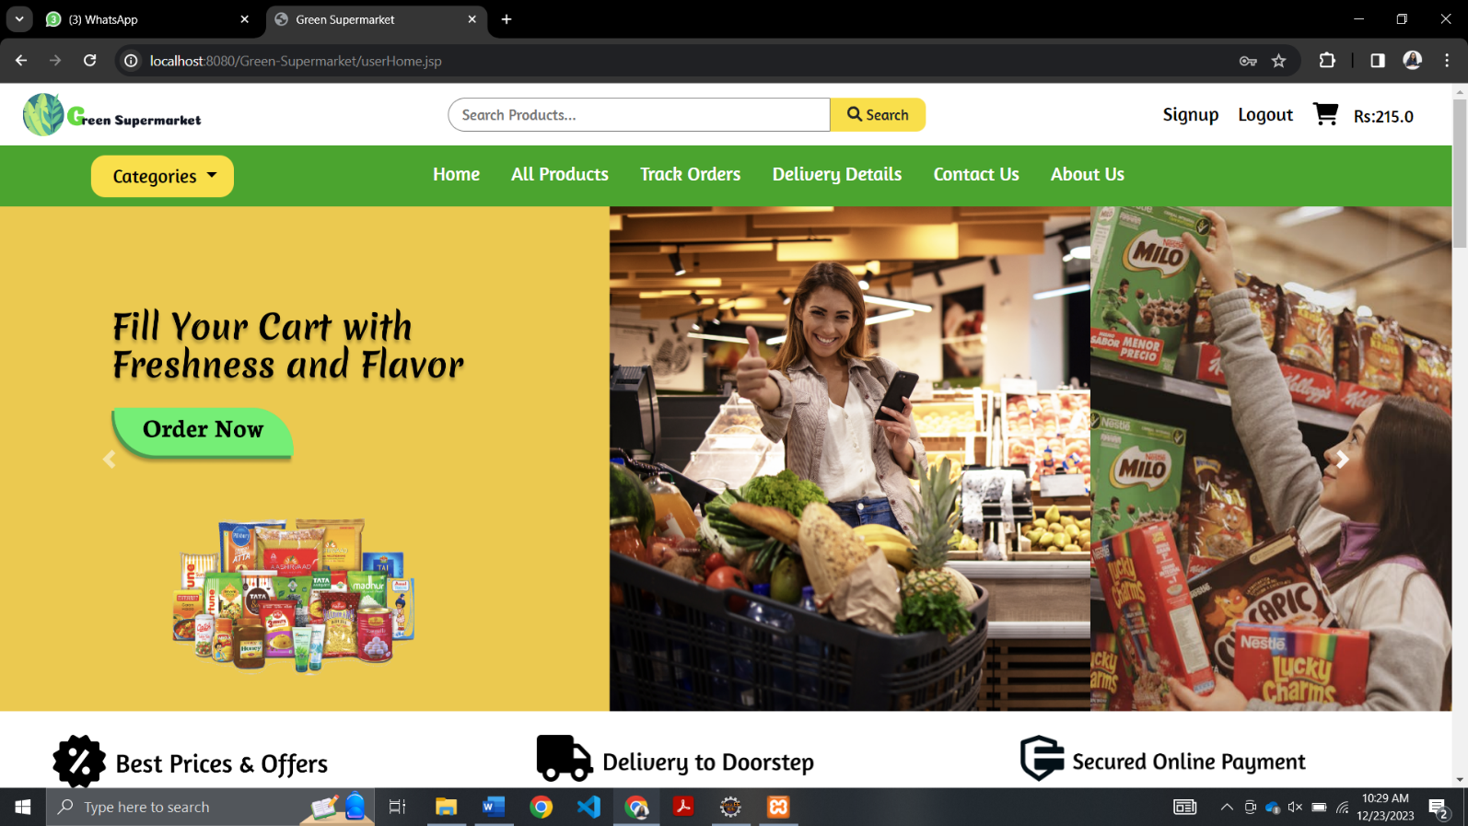

## Home Page for Admin

The admins who are logged in to the website views a home page with a different navigation bar with extra admin options such as Undispatched Orders, Dispatched Orders, Add Products, Update Products and Stock.

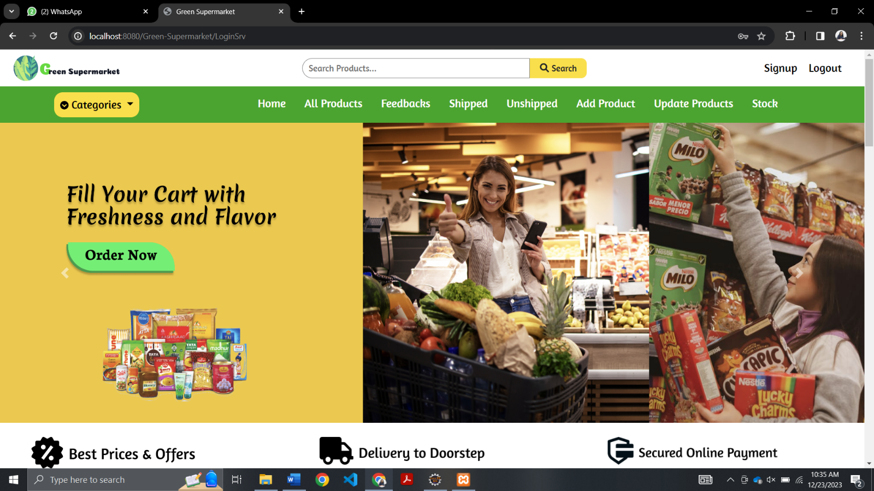

## Category Options

The users have the option to browse products based on the category. Products are categorized into 7 categories as Organic Vegetables, Organic Fruits, Grocery Items, Bakery Items, Biscuits and Snacks, Beverages and Drinks and Beauty and Healthcare.

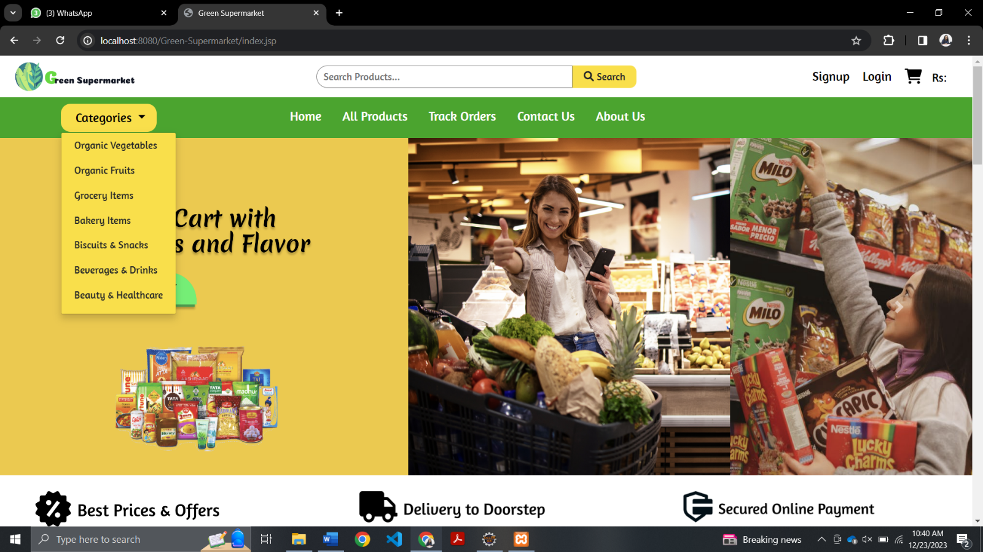

## Category Pages

Organic Vegetables:

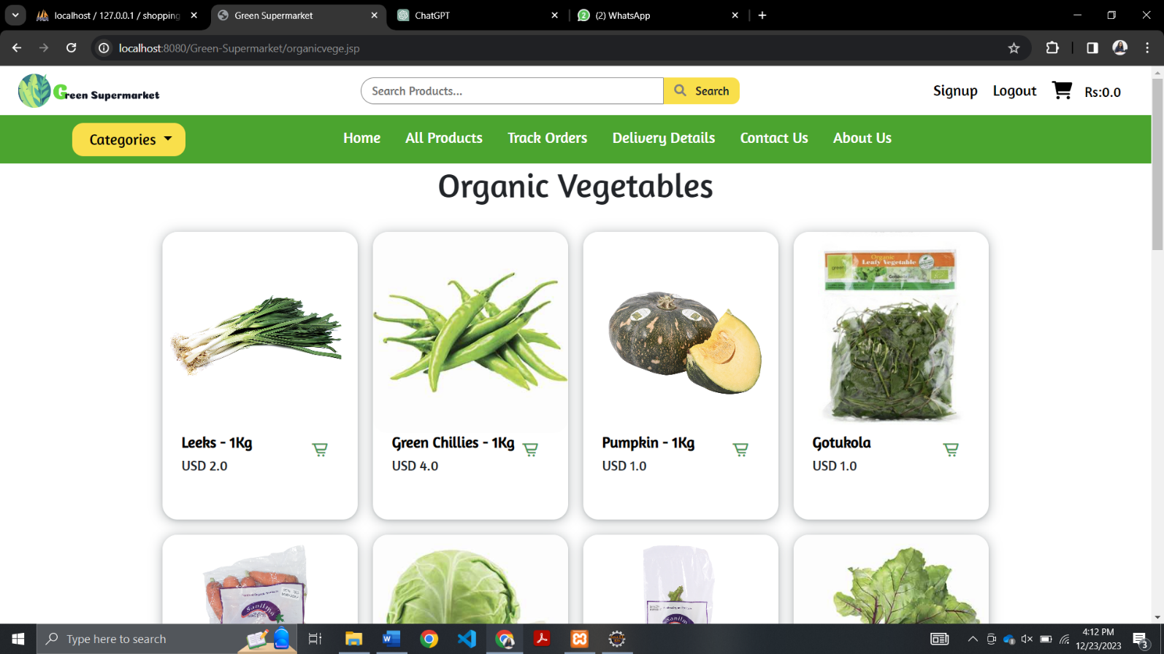

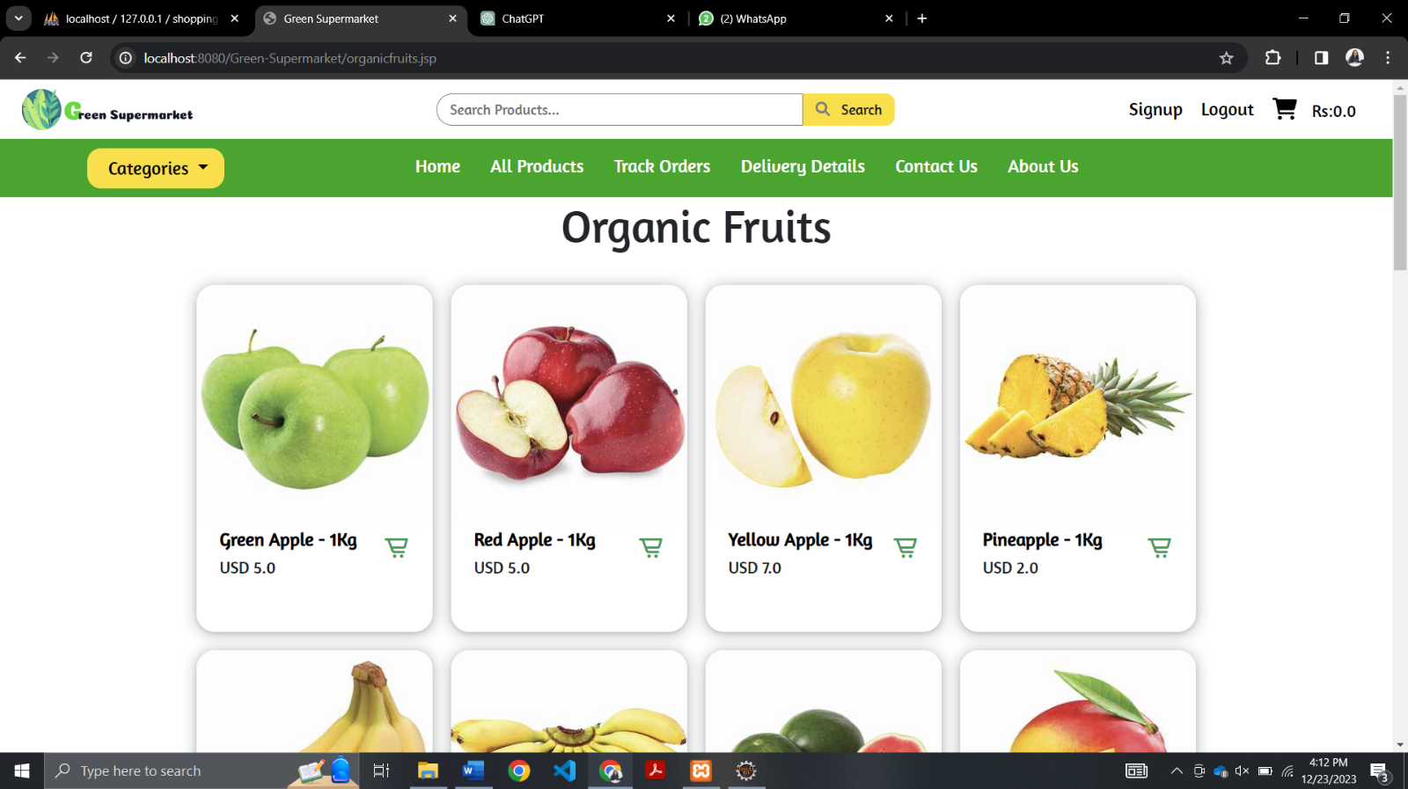Organic Fruits:

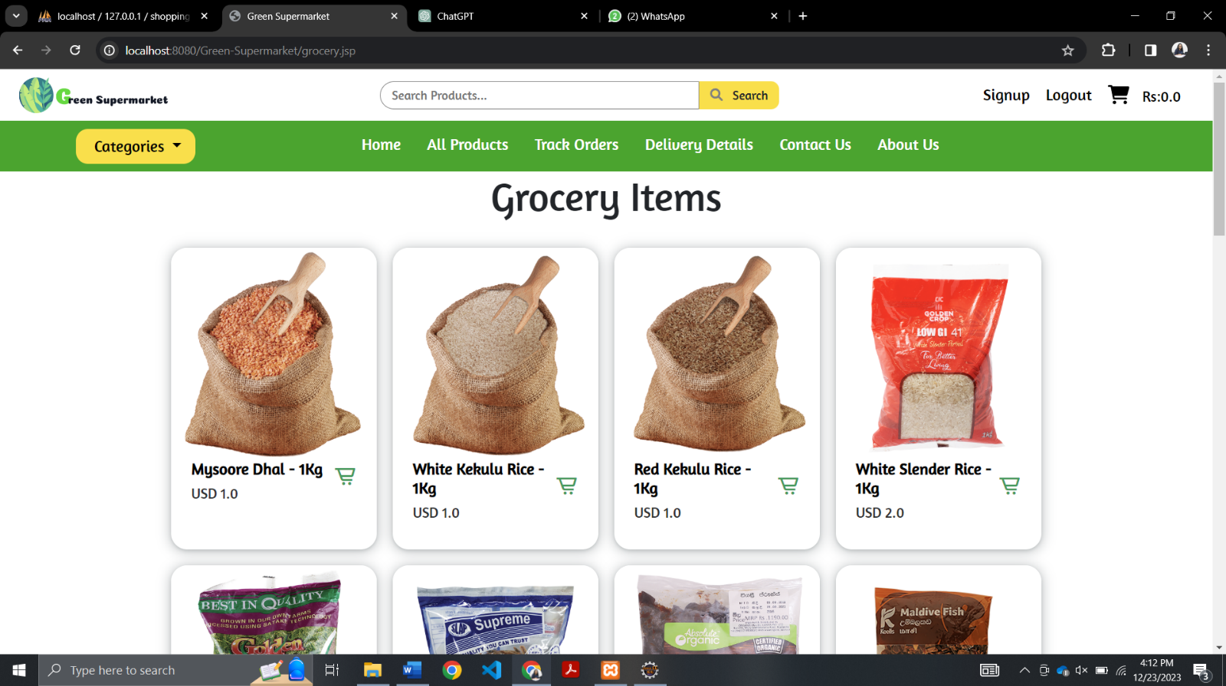Grocery Items:

Bakery Items:

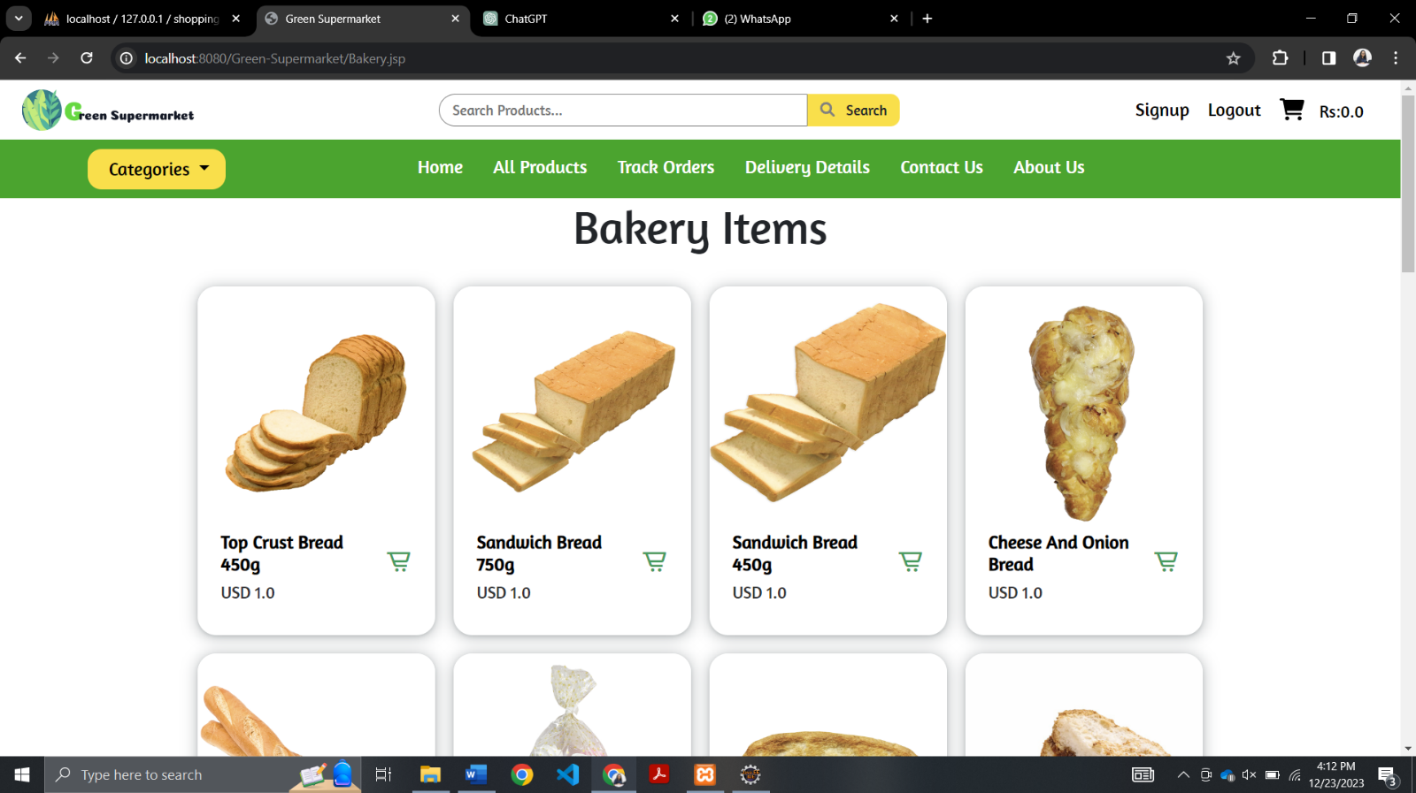

Biscuits and Snacks:

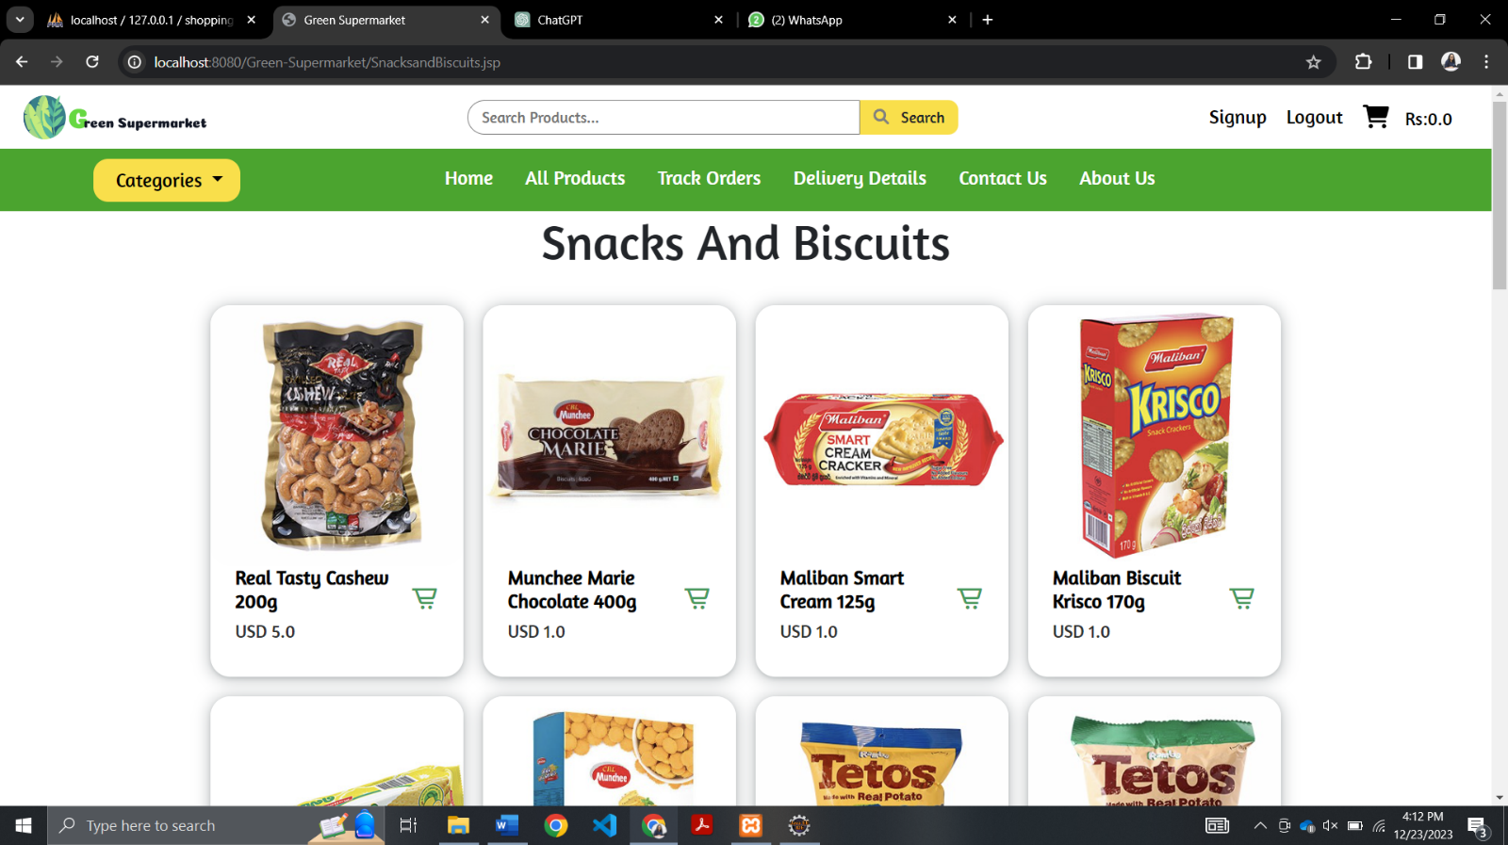

Beverages and Drinks:

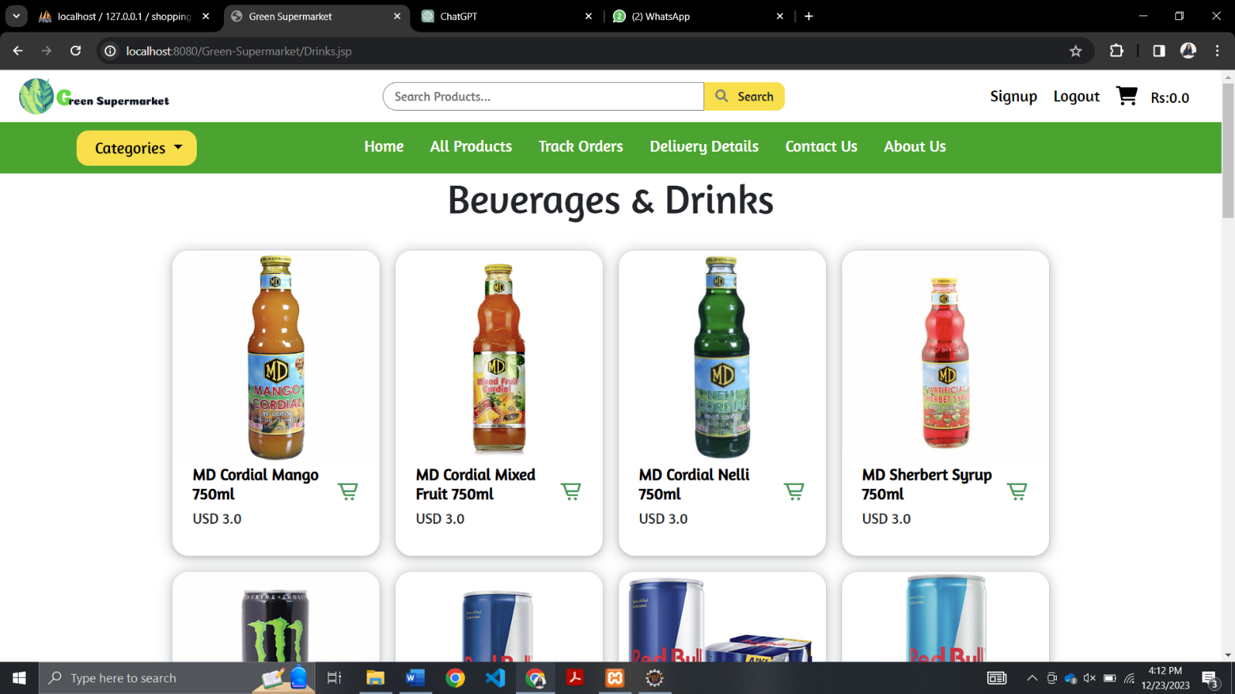

Beauty and Healthcare:

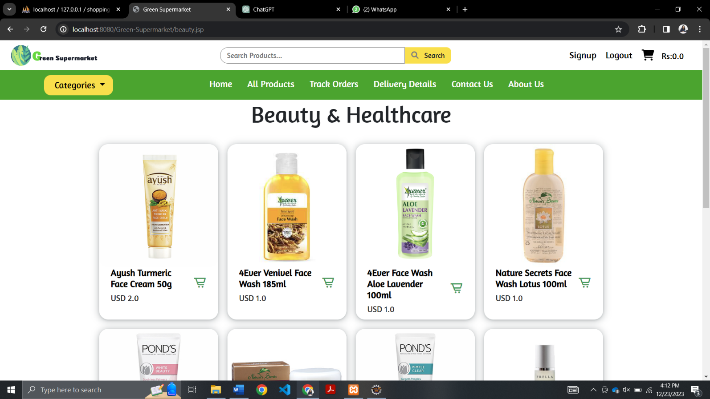

All Products:

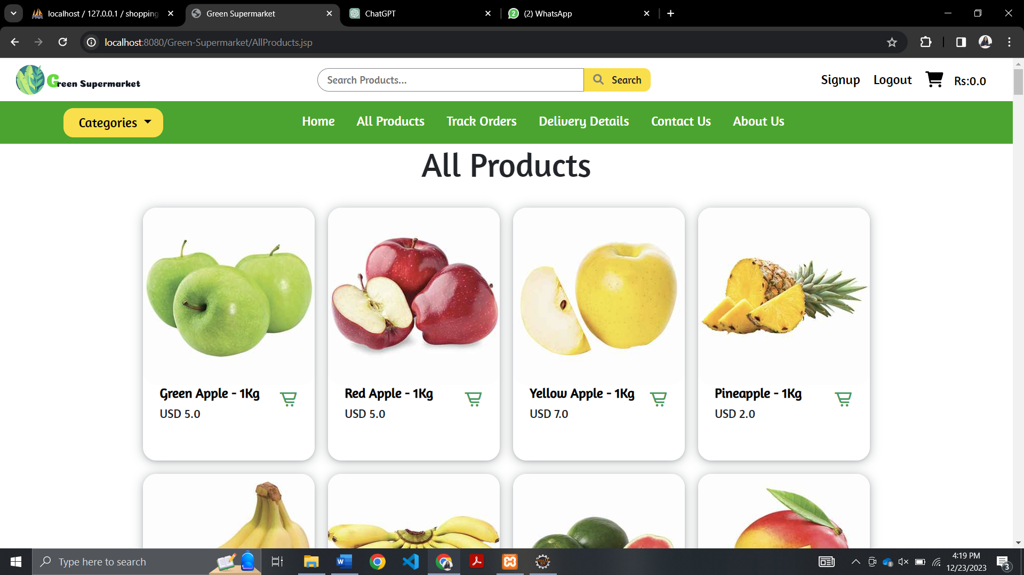

## Sign Up Page

The users can sign up through this sign-up page and create accounts to place orders through the website.

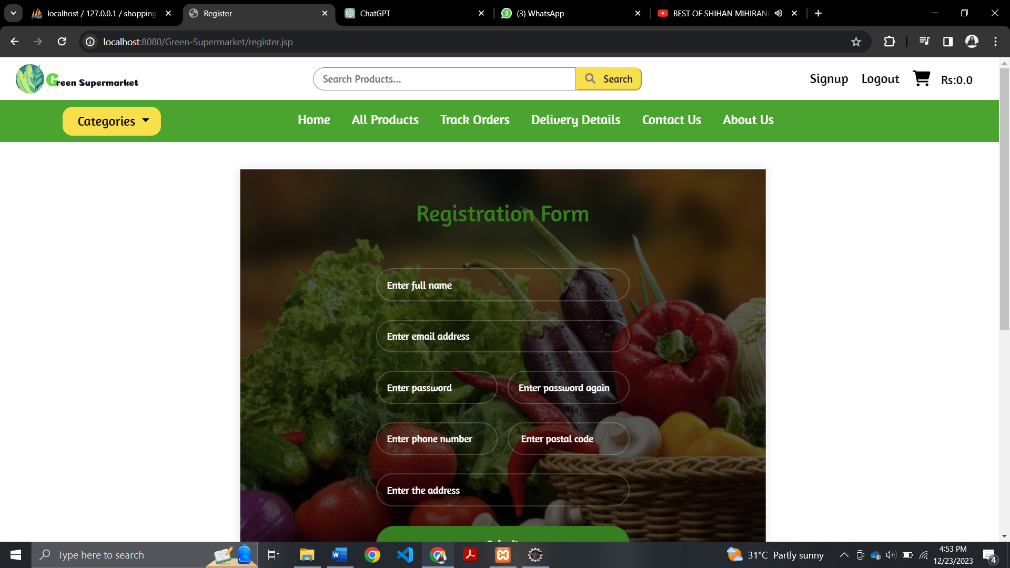

## 

## Login Page

The users who created accounts through the sign-up page can login to their account through the login page and place orders.

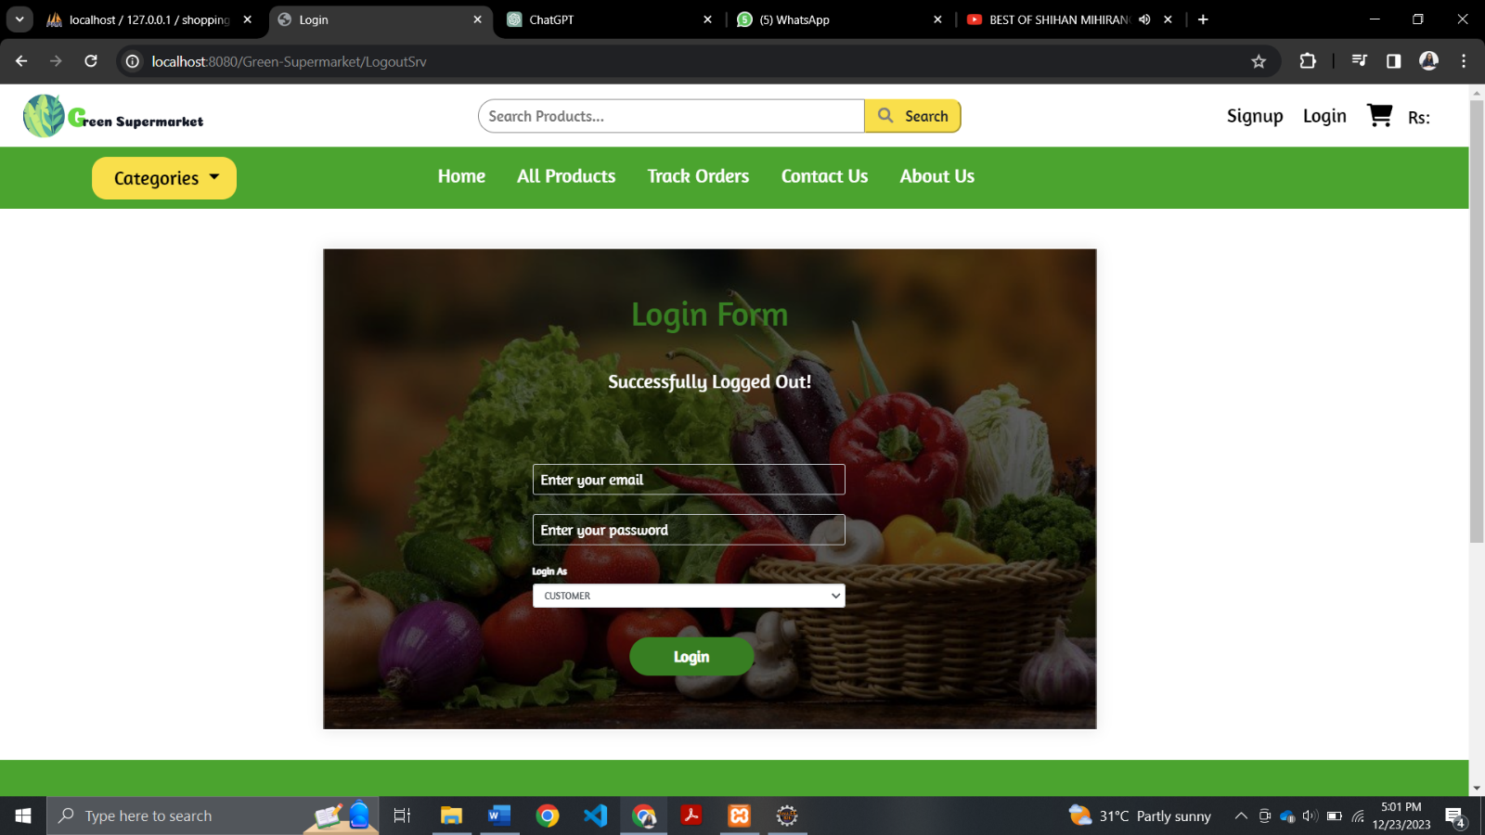

## Track Orders Page

The users logged in to the website can track the orders they placed through the track orders page. Users can track whether their orders are dispatched or not.

## Delivery Details Page

The users can update their delivery details using the form given in this delivery details page.

## 

## Search Function

Users can easily search products using the search bar.

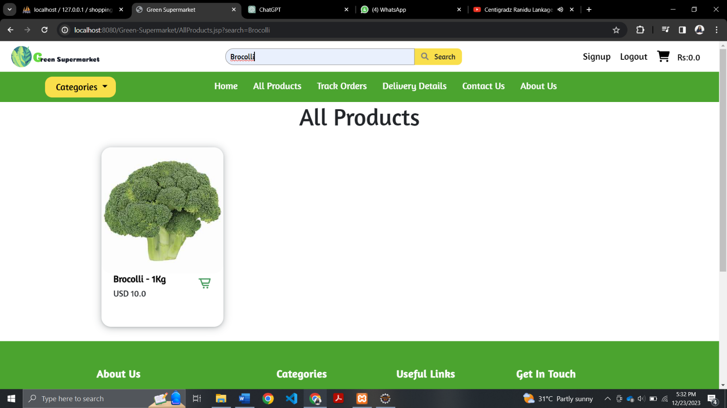

## Cart Page

Users can view their cart items and easily checkout and pay through PayPal or using their debit and credit card details through this page. Users can update the stock quantity they added to the cart from a particular item. Also, they can remove the items from the cart.

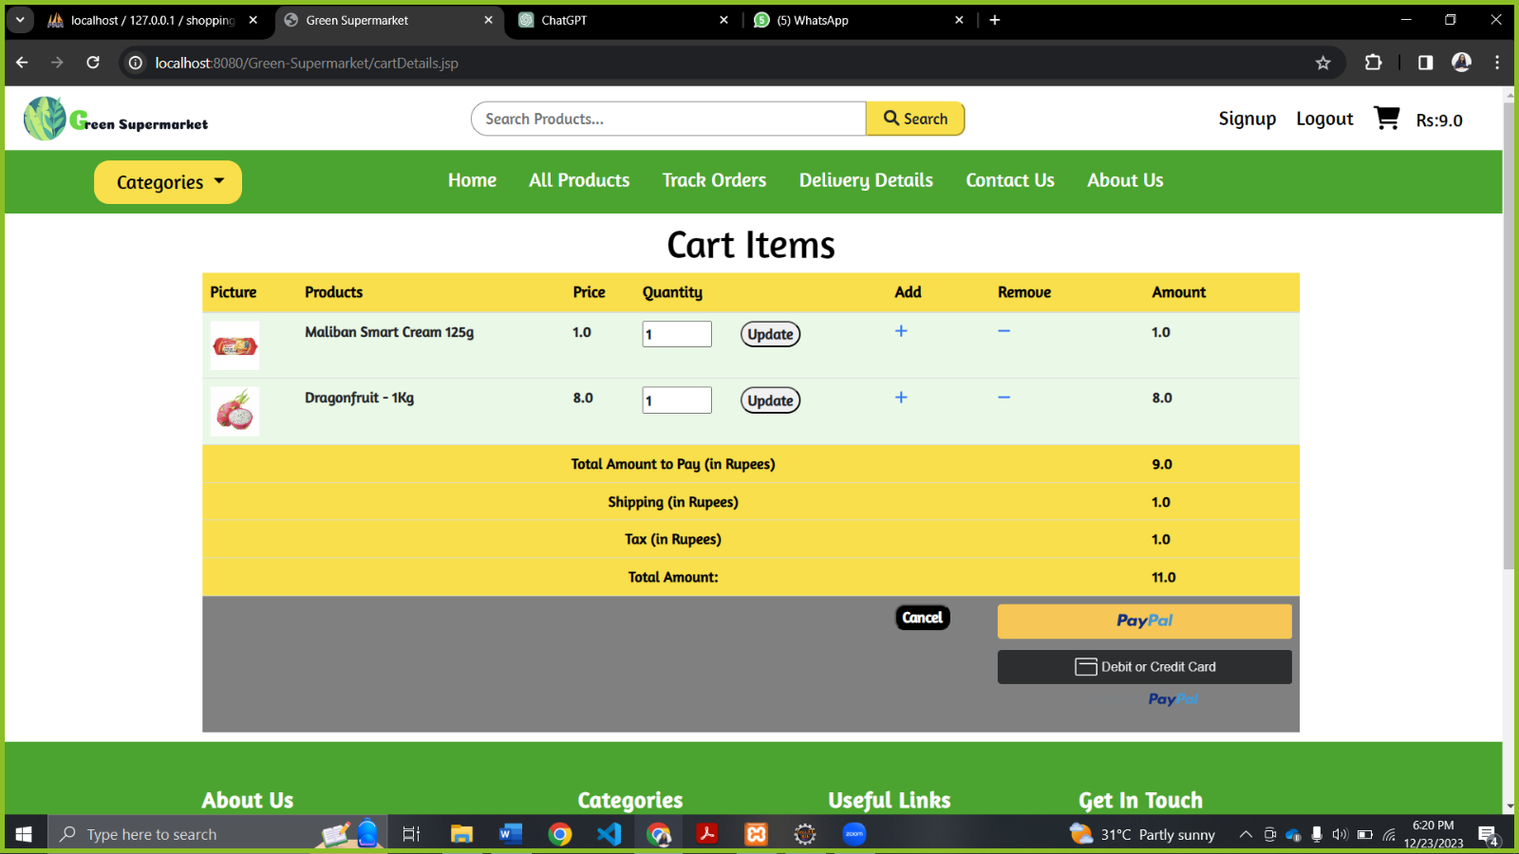

## Avoid Order Collisions

The user will not be able to add a product to the cart which is out of stock.

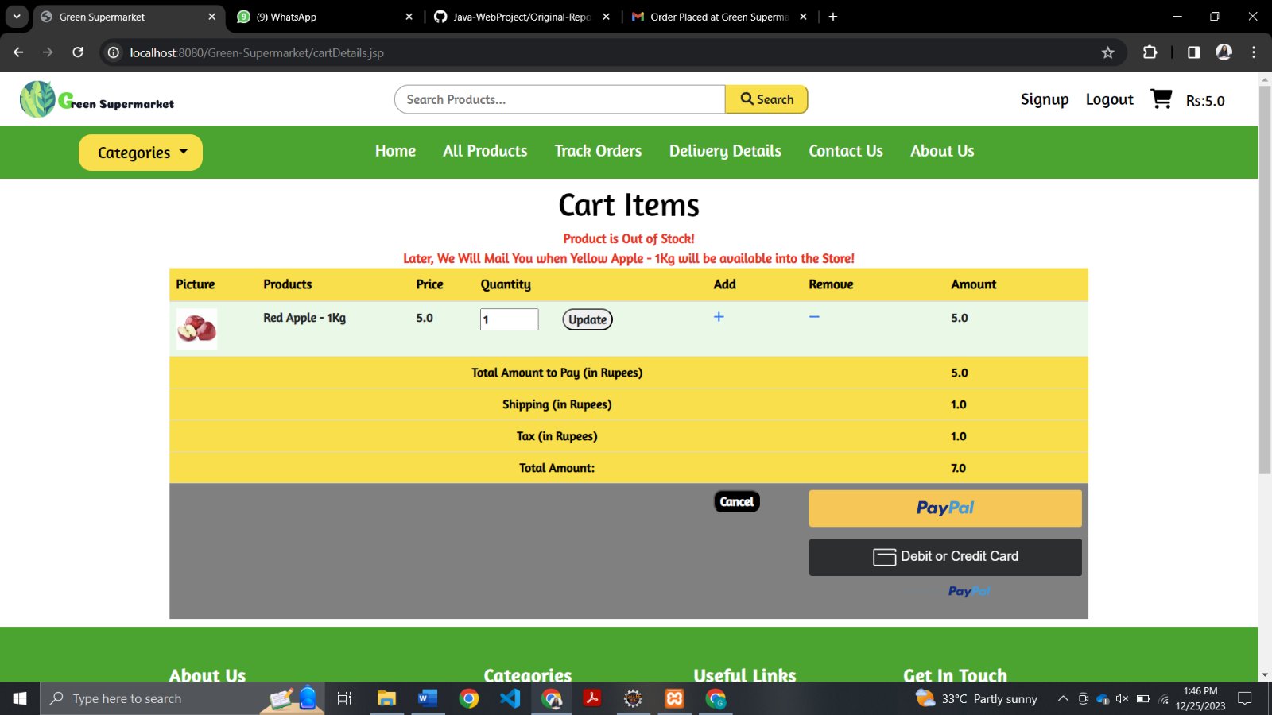

## PayPal Payments

Users can easily make online payments through PayPal payment option.

## Payment Confirmation

After successfully paying through PayPal, users will be redirected to the receipt page where the user will receive a confirmation about the payment. By clicking on the track order button users will be redirected to the track orders page where they can view the details (image of the product, product id, order id, quantity ordered, amount, and the status of the order) of the order placed.

## Feedback Form

Users can send their feedback through this feedback form. All the feedback sent by the users are displayed on the feedback carousel slider. All the users can view all the feedback and the names of the users who sent that feedback, while the admin can view the feedback, name and the email address of the user who sent the feedback.

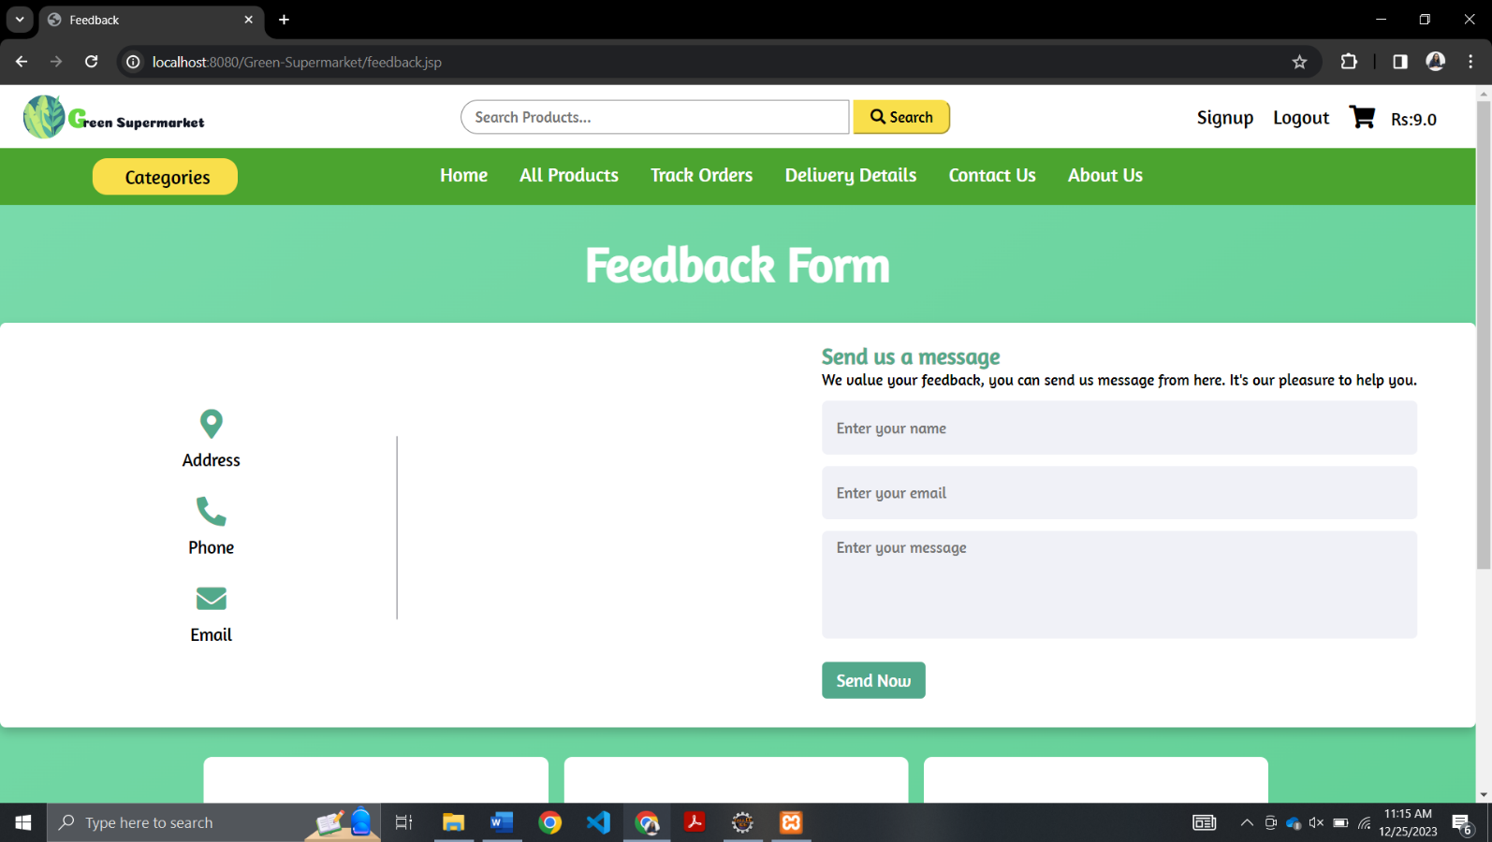

How all users view the feedback:

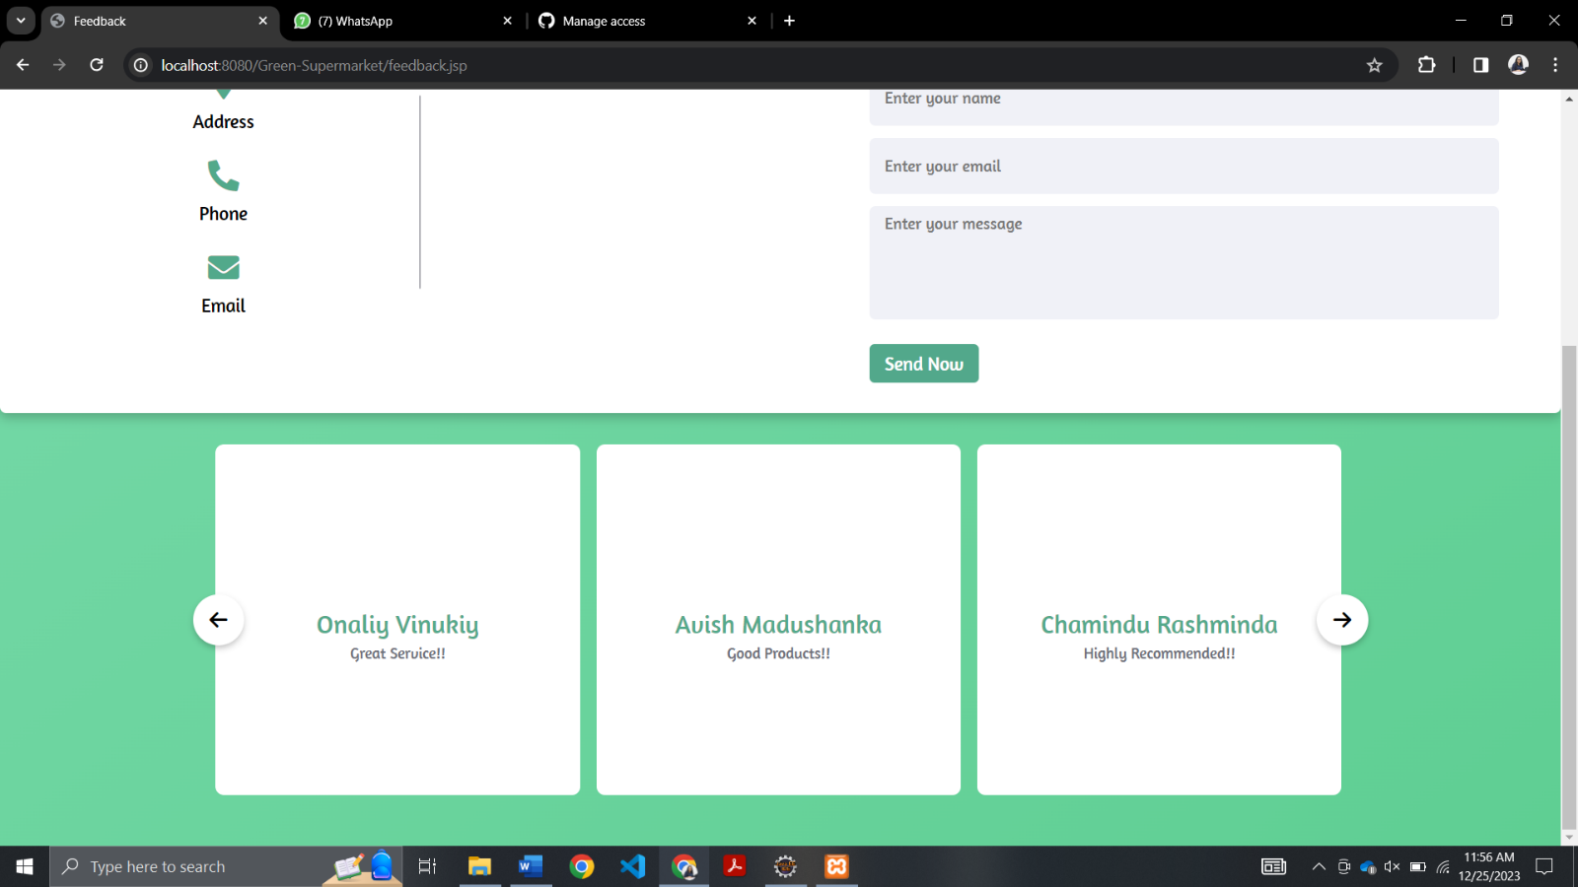

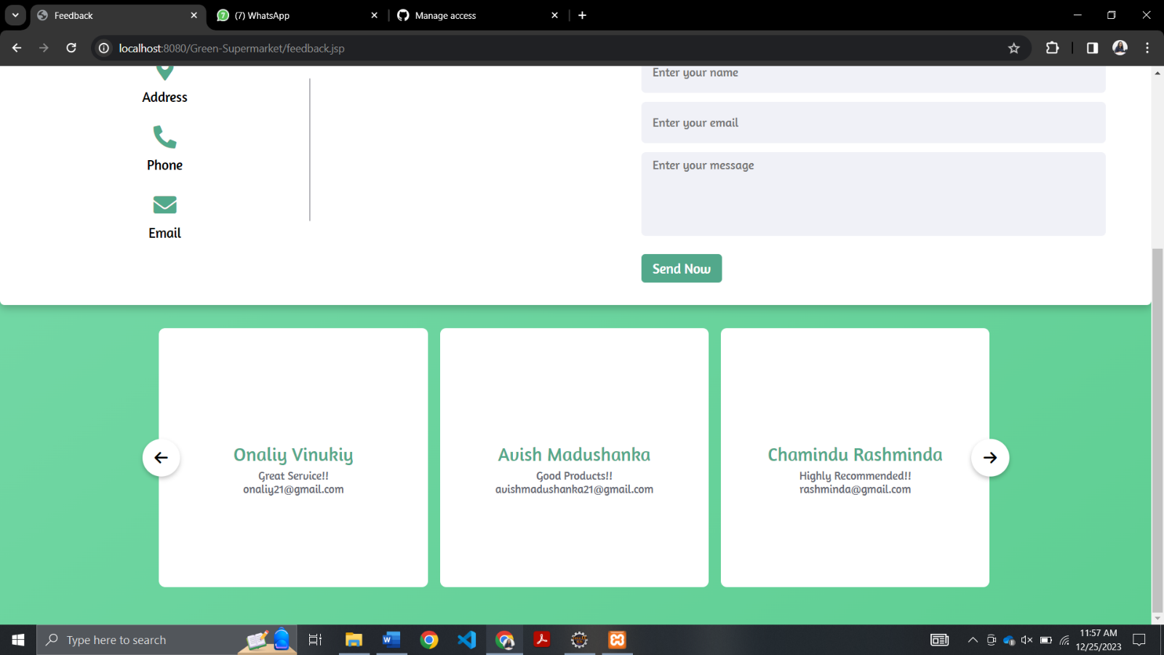How admin view the feedback:

## Product Pages – Admin

The admin gets a separate view of the product pages. The admin has the option to update or remove a particular product through these pages.

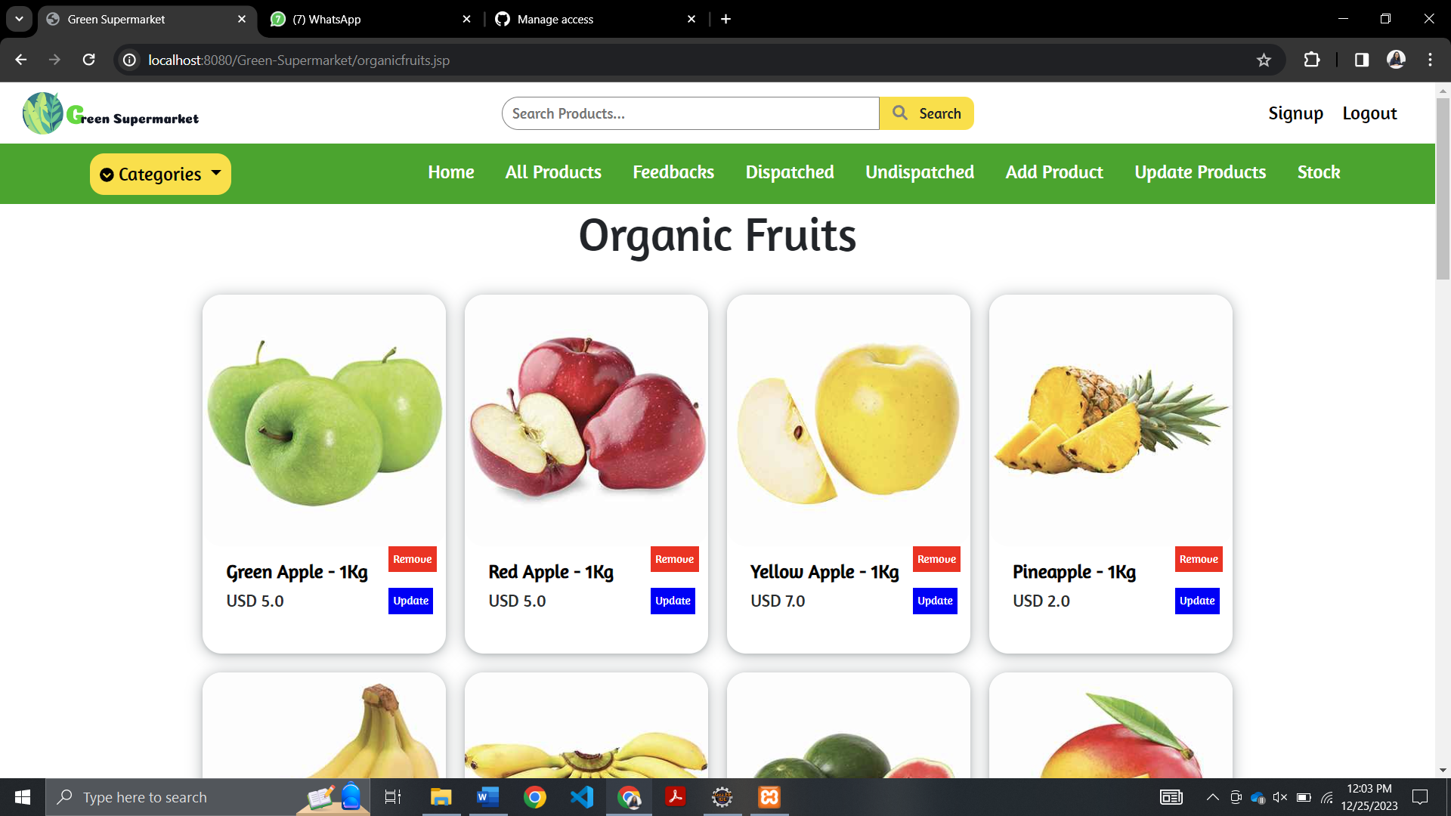

## Add Product Page - Admin

The admin can add new products to the website through this page.

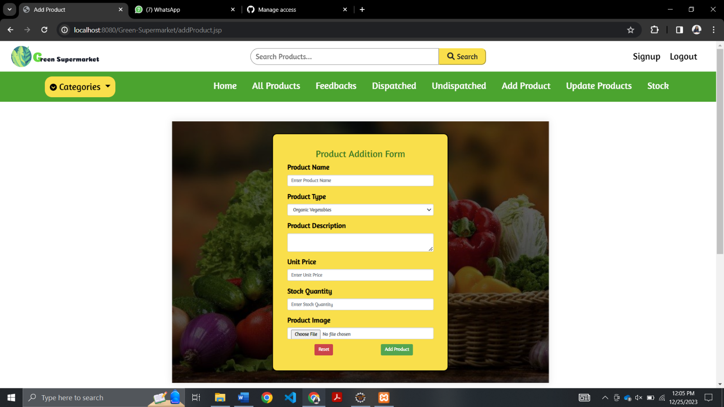

## Update Product Page - Admin

The admin can update the details of the existing products of the website through this update option given for each product.

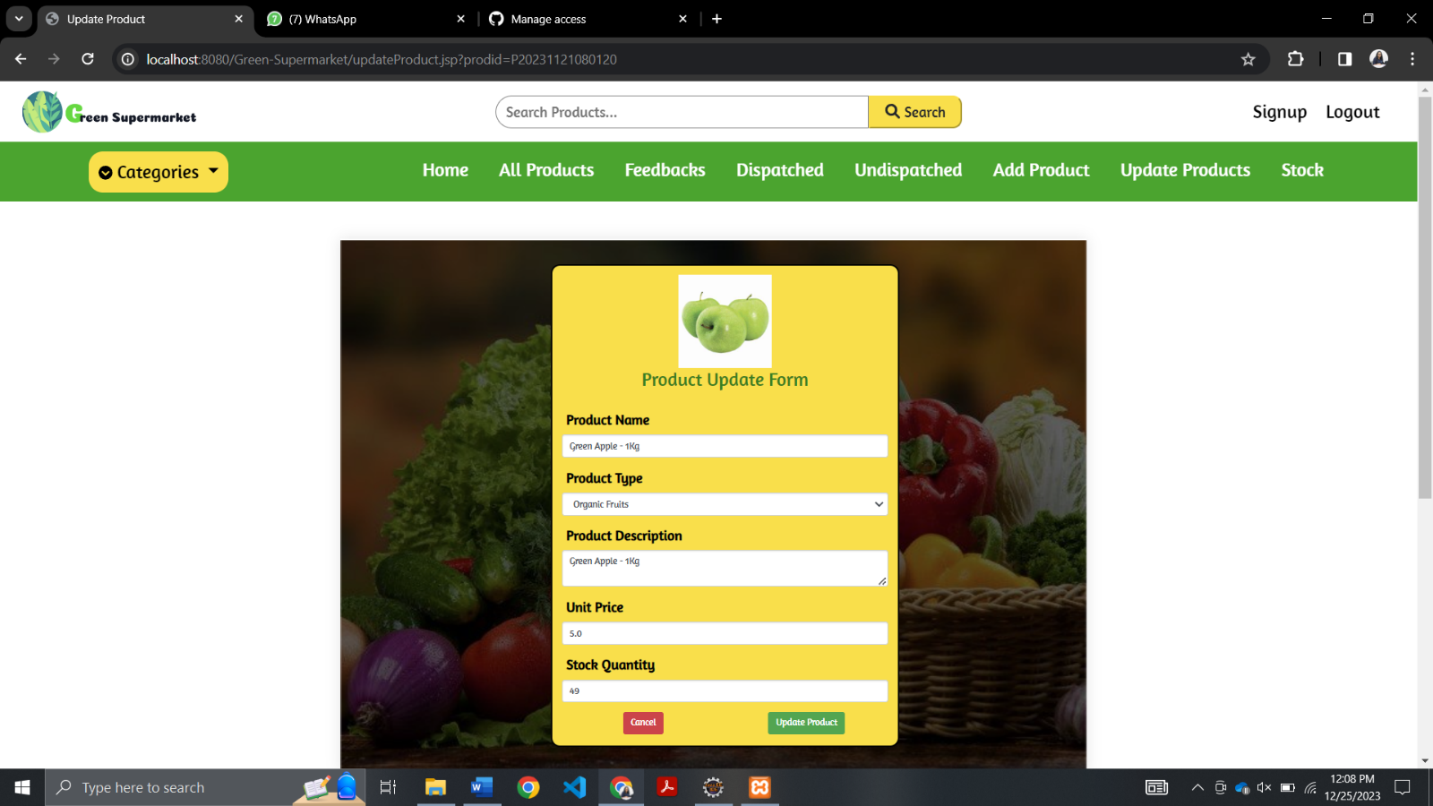

## Delete Product Page - Admin

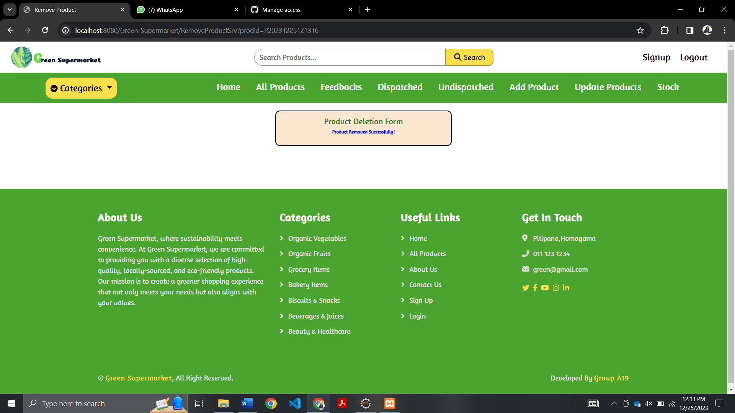The admin can delete existing products through the remove option given for each product.

## Dispatched Items Page – Admin

The orders which are dispatched are displayed in this page.

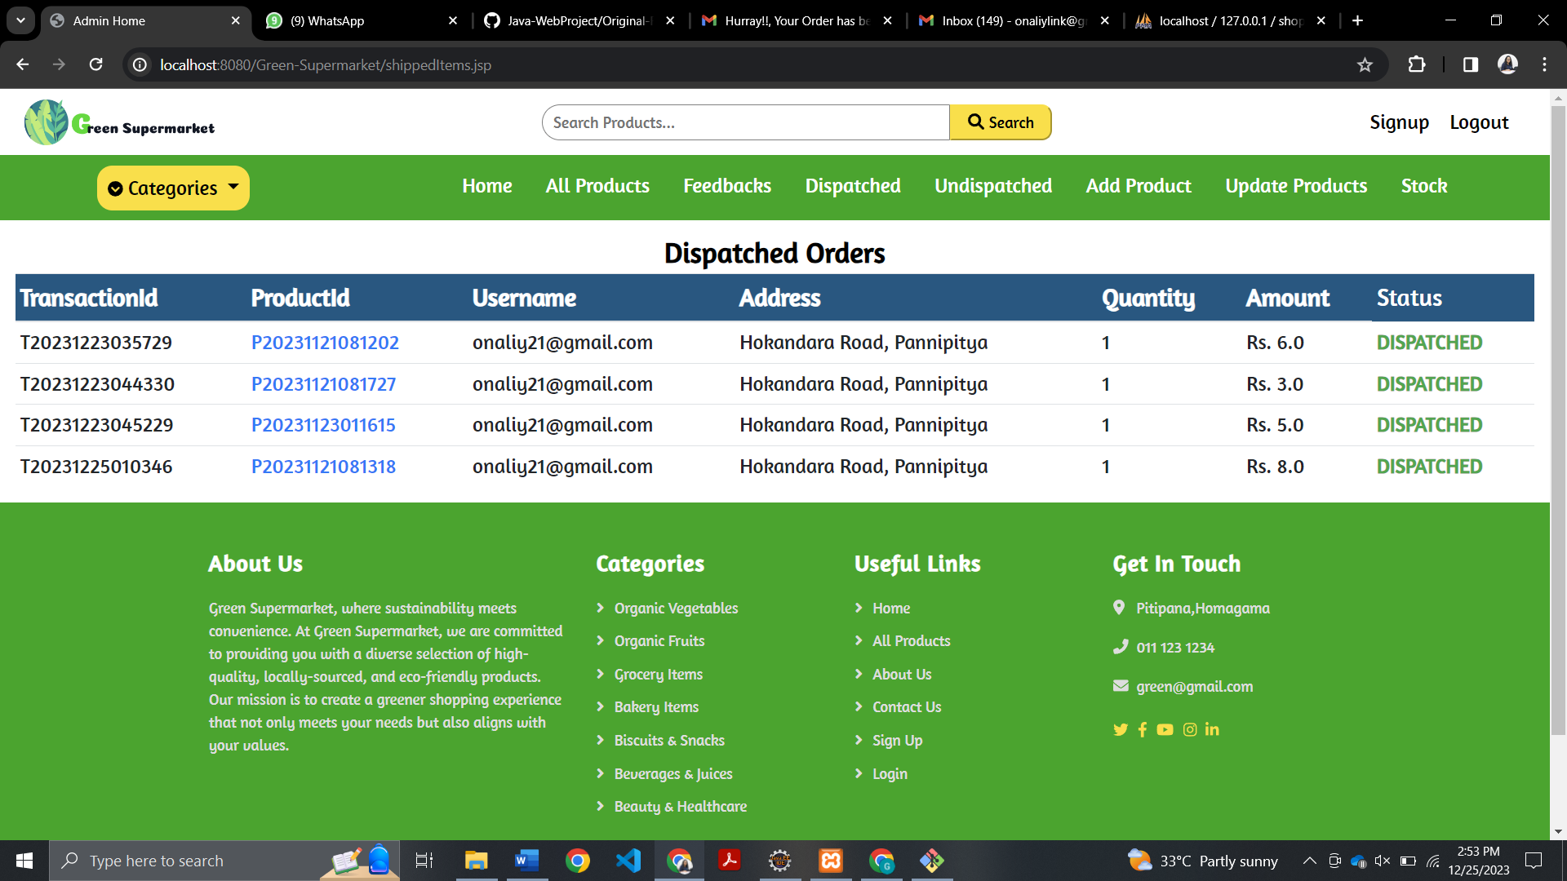

## Stock Page - Admin

Through the stock page the admin can view all the details about the available products and the remaining stock quantity. The admin can update these details including the stock amount as well as remove products through this page.

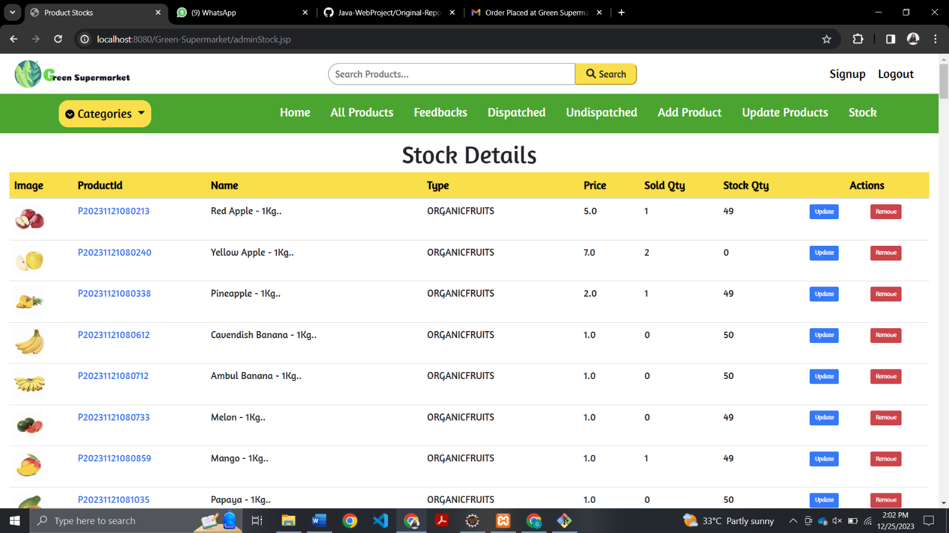

## Un Dispatched Item Page – Admin

The admin can view all the orders placed by users, and not yet dispatched in this page. Once the order is dispatched, the admin can mark them as dispatched. Then the order record will be removed from this page and will be sent to Dispatched Items Page.

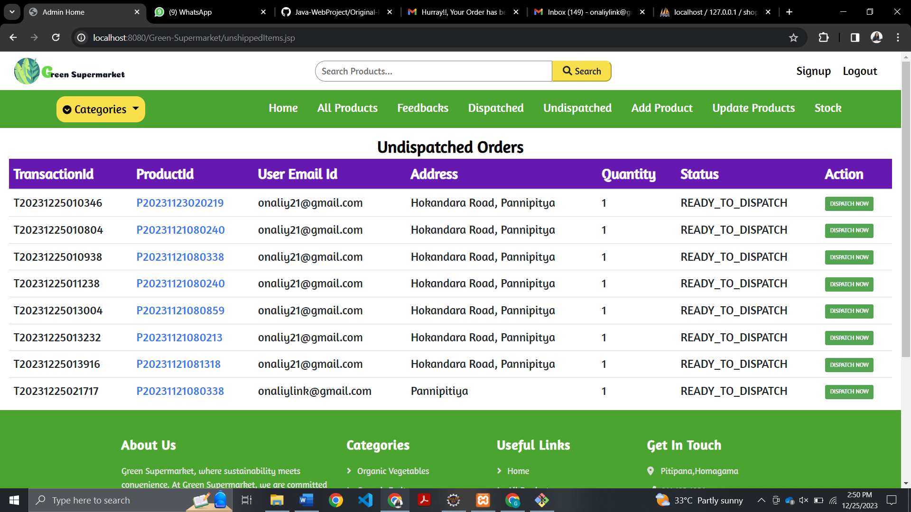

## Email Notifications

Users will receive an email once they get registered with the website.

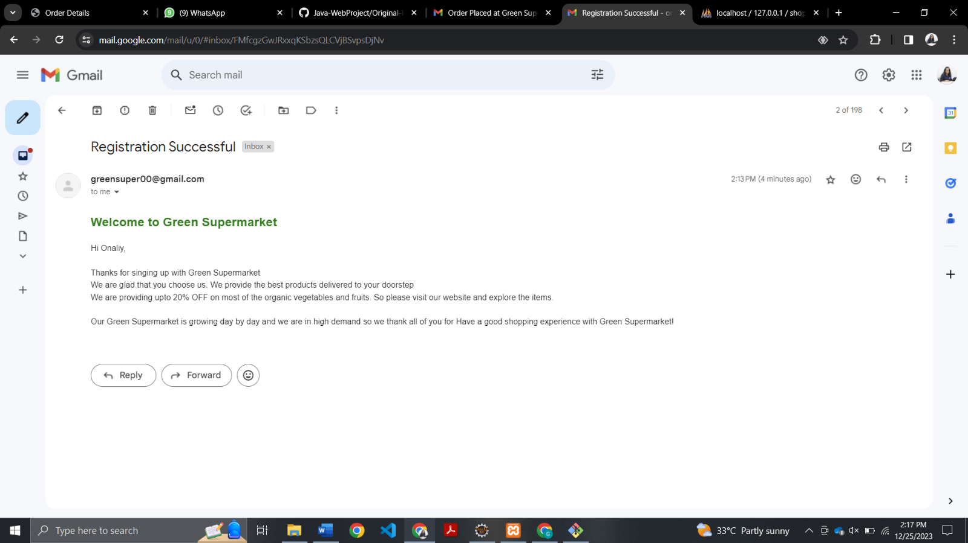

Users will receive an email once they successfully placed an order and made the payment through PayPal.

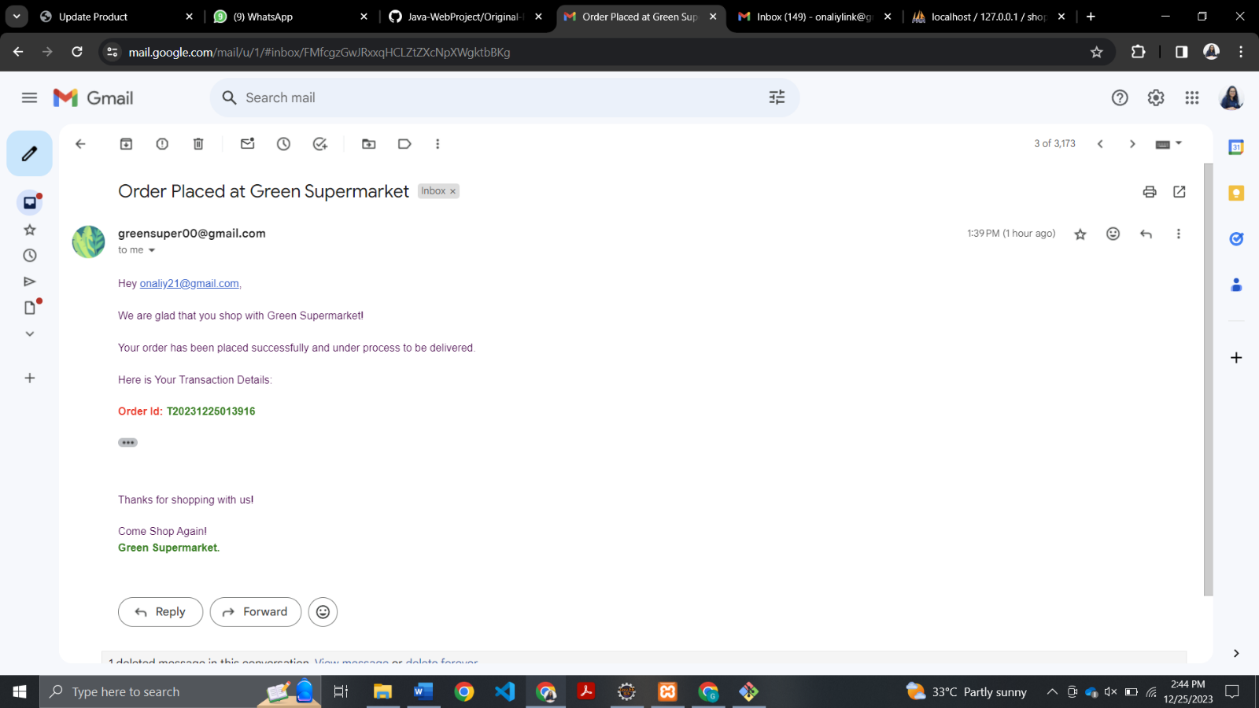

Users will receive an email once their order is dispatched.

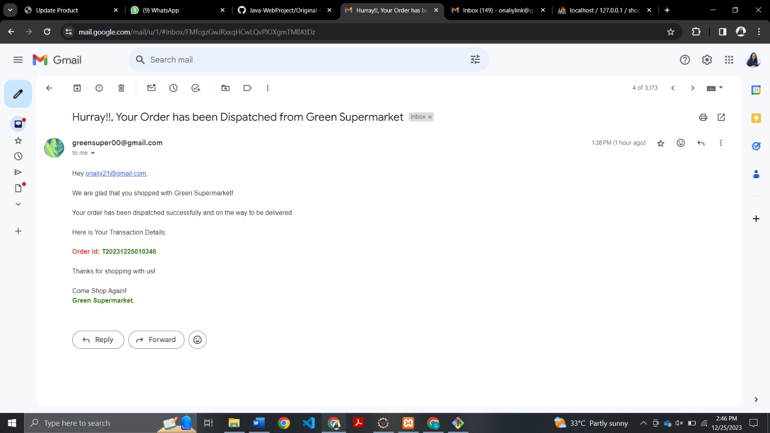

Users will receive an email once the products they tried to add to the cart, and which were out of stock are restocked.

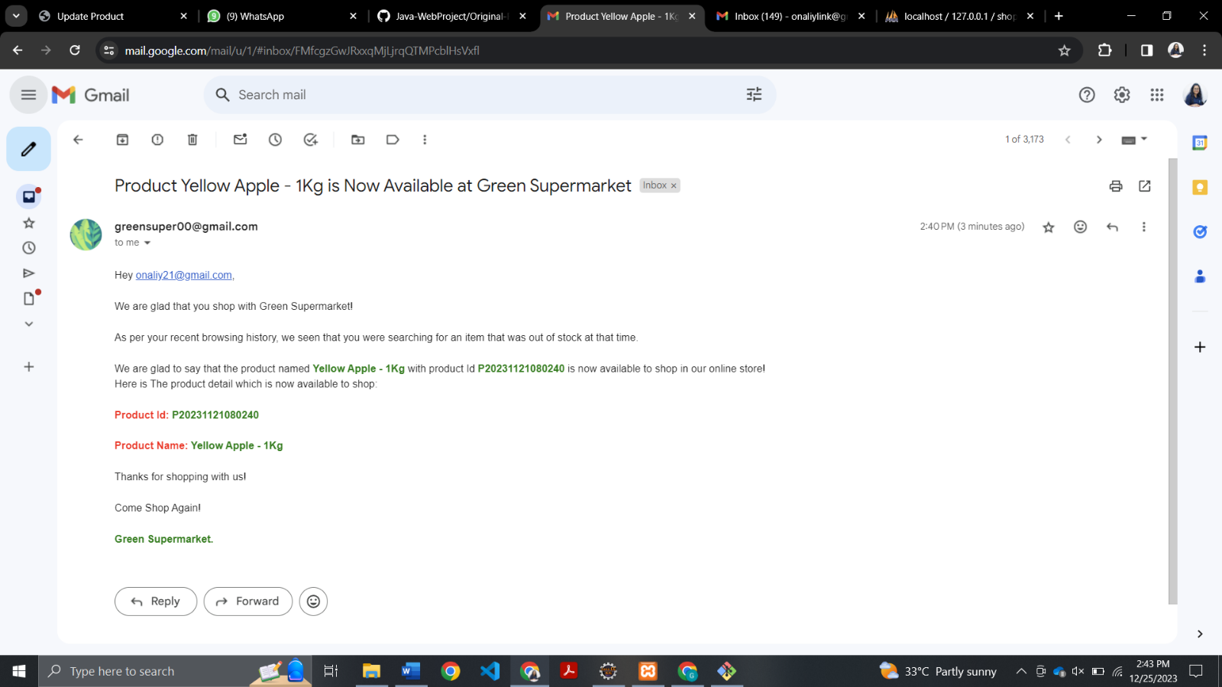

## Our Team



